**Step 1:**

**Step 2: Create Blueprint**

**Step 3:**

**Step 4:**

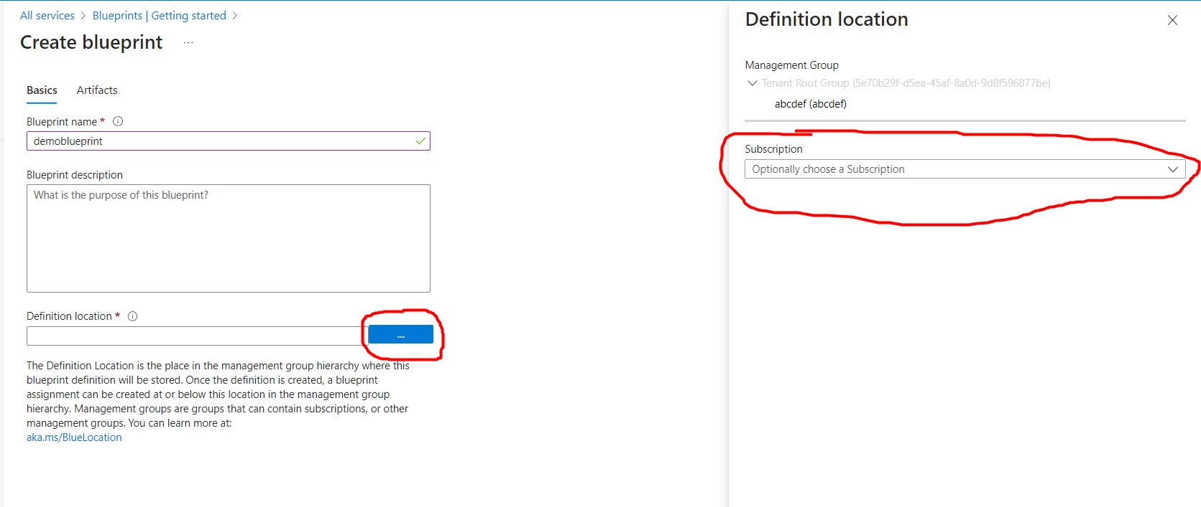

Step 5:

Step 9:

Step 10:

Step 11:

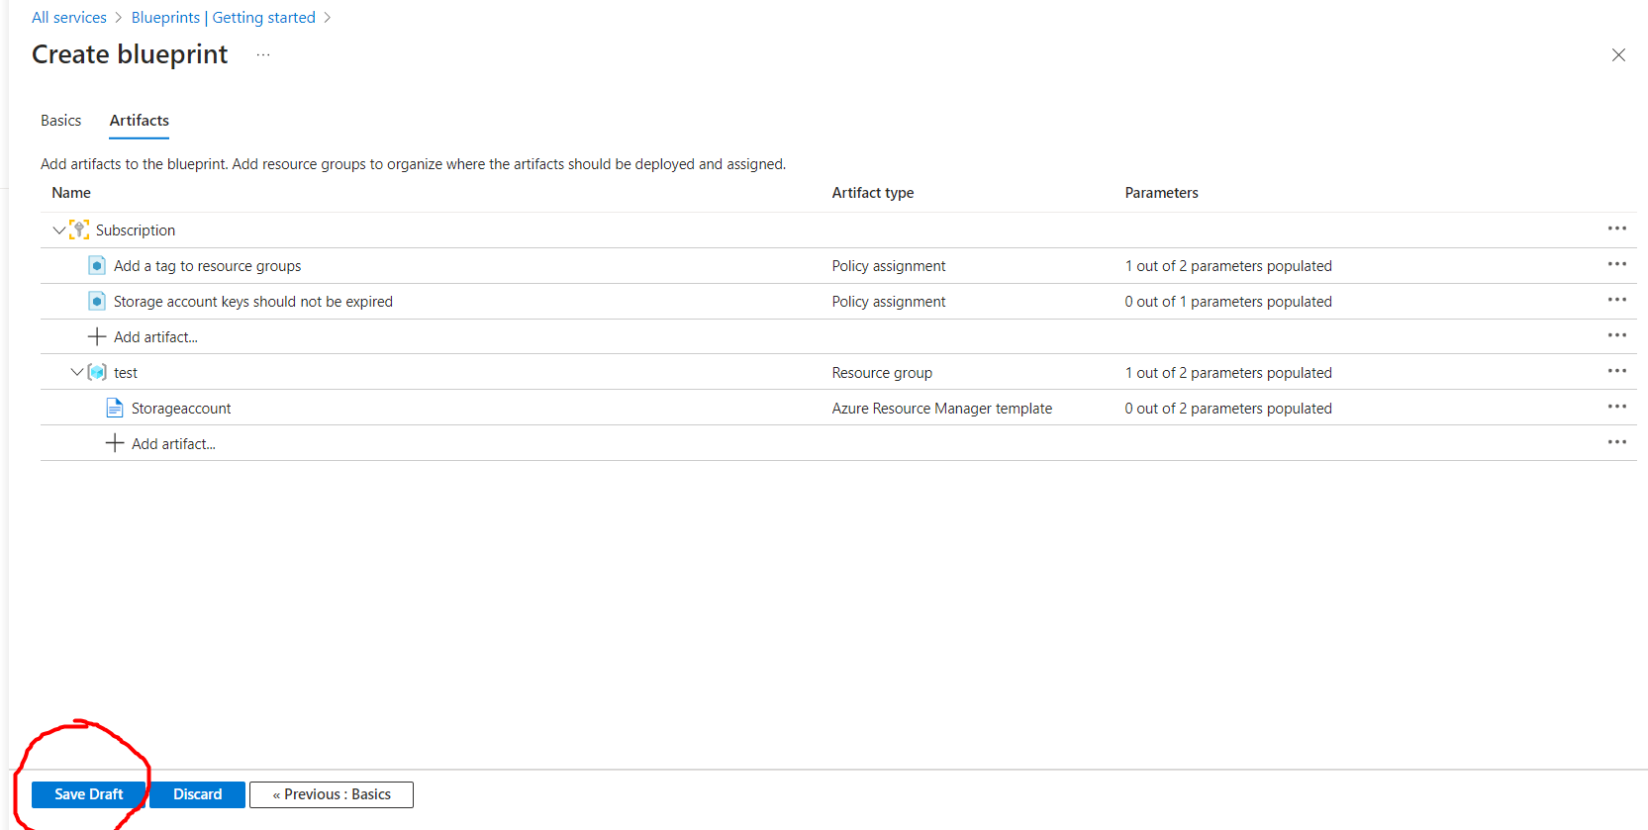

Step 12:

Step 15:

Step 16:

Step 17:

Step 18:

Step 20:

Notification Area:

Step 21:

Step 22: New Resource Group

Step 23:

Step 25:

Step 27:

